**Part 1**

Follow the below steps:

1. Start off by deleting the entire collection cars.
   * Take a screenshot of the query *as well as* the list of your collections in Atlas to be sure this collection has been deleted.
2. Next, run the following query to recreate the cars collection.
   * A picture containing graphical user interface

     Description automatically generatedThe following includes more cars than before. Graphical user interface

     Description automatically generated

**1**

1. Create an index on the price field.
2. Create an index on the non-used field for the cars collection.
3. Find and delete all documents with a year before 2012.
   * Be sure to do a find with your filtering criteria first to be sure you're about to delete the correct documents.
4. Delete the first document that is a BMW.
5. 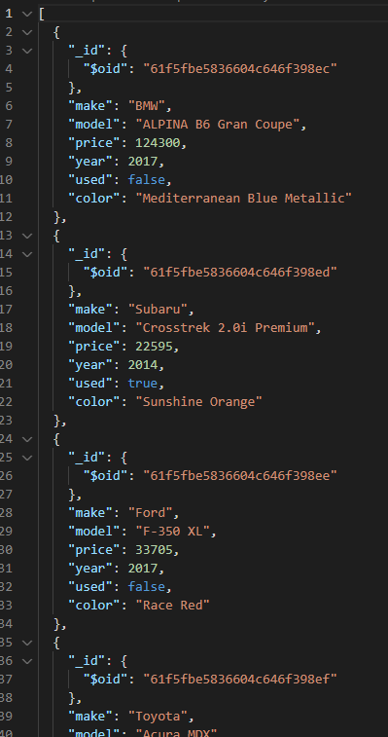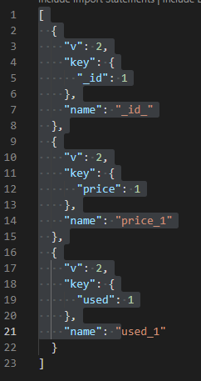Drop the index created on the non-used cars created above.

**5**

**3 & 4**







## Part 2

Below is a real-life scenario. Please read this scenario and run the appropriate queries needed.

You are currently working for a car dealership. They sell both used and new cars. The company would like to easily and efficiently search through their cars using the "make" of the car. Recently, they made the searching efficient using the price of the car, but that is no longer needed since they will now be using the make of the vehicles. Please reflect that in the database. Also, the company has decided to no longer sell Volkswagens and has already sold the last Volkswagen on the lot so they would like you to reflect that in the database as well.

